Parth Babbar

Cashier check

Introduction:
Cashier's checks are a secure and dependable form of payment that are guaranteed by the issuing bank. Unlike personal checks, cashier's checks are drawn directly from a bank account, guaranteeing that the payee receives guaranteed monies. A cashier's cheque is issued by a bank or credit union on behalf of a client and provides a secure alternative for significant transactions, assuring the receiver that the money are secure and guaranteed by the financial institution.
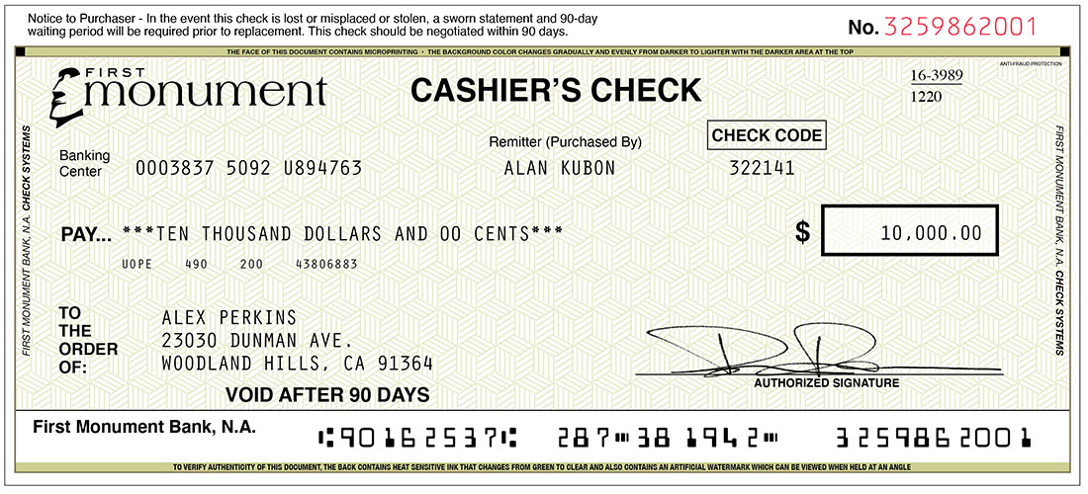
Process:
- Request: The payer asks a cashier's cheque from their bank, indicating both the recipient and the amount.
- Funds: The payer pays the bank the full amount of the cheque, plus any relevant fees.
- Issuance: The bank withdraws monies from the payer's account and issues a cashier's cheque payable to the designated recipient.
- Guarantee: The bank guarantees the cheque, so the beneficiary will receive the monies.
Uses & Benefits:
- Security: The main benefit of cashier's checks is their security. They are less prone to fraud than personal checks since they are issued by a bank.
- Significant Transactions: They are great for significant transactions when the receiver needs to know that the money are accessible, such as real estate purchases, automobile sales, or substantial corporate deals.
- Acceptance: Because of their assured nature, they are frequently accepted where physical checks or electronic transfers are not.
- Versatility: Can be used for both local and foreign transactions, giving you more freedom in your financial dealings.
Challenges & Drawbacks:
- Costs: Cashier's checks frequently come with issuance costs, which might be greater than other payment options. Additional costs may apply for overseas transactions.
- Inconvenience: Obtaining a cashier's cheque usually needs a visit to a bank branch, which can be unpleasant when compared to electronic payment alternatives.
- Fraud: Cashier's checks, while typically safe, are susceptible to fraud. Scammers can produce counterfeit checks, and determining the legitimacy of a check can be difficult.
- Processing Time: Cashier's checks might take some time to clear, particularly if they are utilised in overseas transactions or the bank wants to verify the money.
Fees & Charges:
- Issuance Fees: Banks normally charge a fee to issue cashier's checks, which varies based on the institution and the size of the check.
- Extra costs: Cashier's checks issued in foreign currencies or utilised in overseas transactions may be subject to extra costs.
Security Measures:
- Fraud Prevention: Banks use a variety of security measures to prevent counterfeit cashier's checks and assure the validity of issued checks.
- Verification: Recipients should confirm the legitimacy of cashier's checks by contacting the issuing bank immediately, especially for significant sums.
Statistics:
- In 2022, US banks issued around 18.5 million cashier's checks.
- The average value of a cashier's cheque varies but is usually greater than that of a money order, ranging from $1,000 to $10,000 or more depending on the transaction purpose and banking institution restrictions.
Conclusion:
Despite the increasing use of electronic payment systems, cashier's checks remain a reliable and safe form of payment for some sorts of transactions. However, there are certain drawbacks, such as costs, the possibility of fraud, and the trouble of acquiring them. Understanding their applications, prices, security features, and potential downsides is critical for both consumers and enterprises.

